Nagios is one of the most widely used tools for Continuous Monitoring

**Need of monitoring**

* High availability
* Reduce down time
* Adding redundancy to the system
* Support both physical/virtual machines

**Why Nagios**

* Check to see if a server is running up or down
* Notify if server is down (by email/SMS/)
* Check to see if server is running (mail, http, pop, ssh)
* Check to see if process or services (windows) running
* Gather performance statics on server
* Allow specific alerts to only go to particular groups / individuals
* Get reports of downtime on server

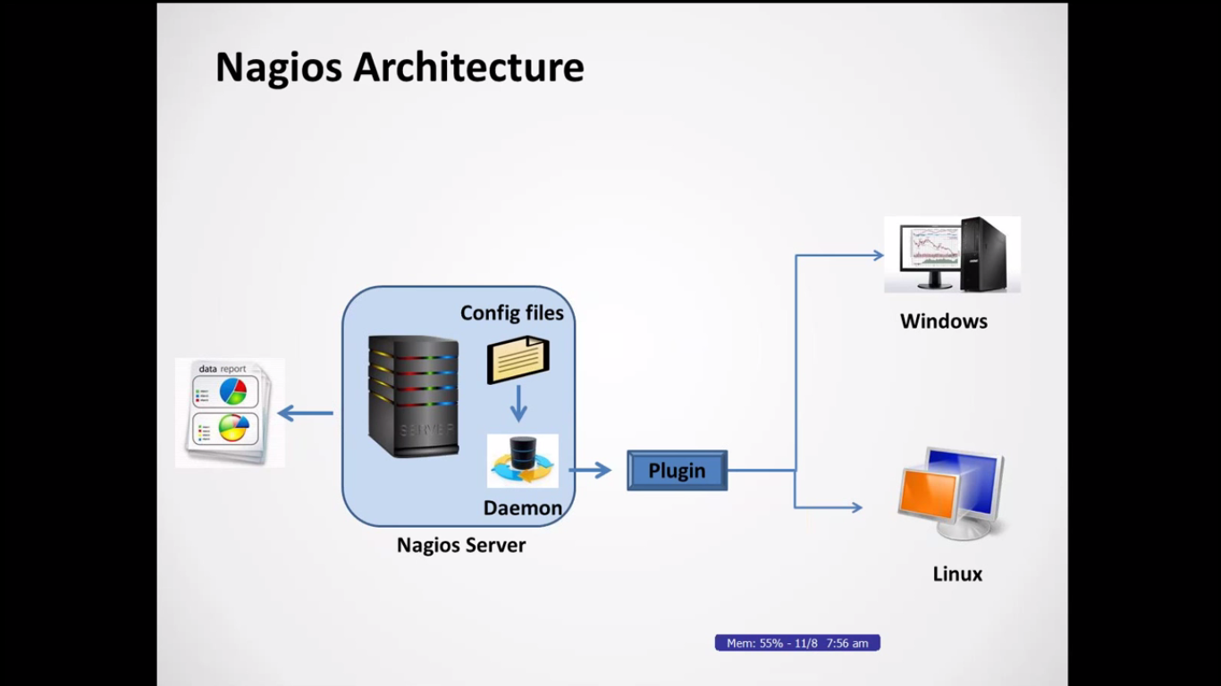

**-**first setup Nagios server

- Nagios server monitor using some set of configuration files, it having lot of (grp of) configuration files specific to the task. Each configure file having what kind of things we have check OR monitor.

- internally it has daemon (background) process, this daemon read the configuration file and connect to remote host using appropriate plugin and periodically checking what we have specified time. Those details also configure on configuration file.

- here plugin defines

-

**Prerequisites (for run server)**

* Apache (httpd) (for run dash boards)
* PHP (need this for show the dash board)

(Nagios will give the raw code, take this code and compile, when we are download any one, we are looking for binaries, but Nagios will download source code and compile)

* GCC Compiler (gcc, glibc, glibc-common)
* GD
* Perl
* Make

yum install httpd php gcc glibc* gd gd-devels (you have to run this command from /root)

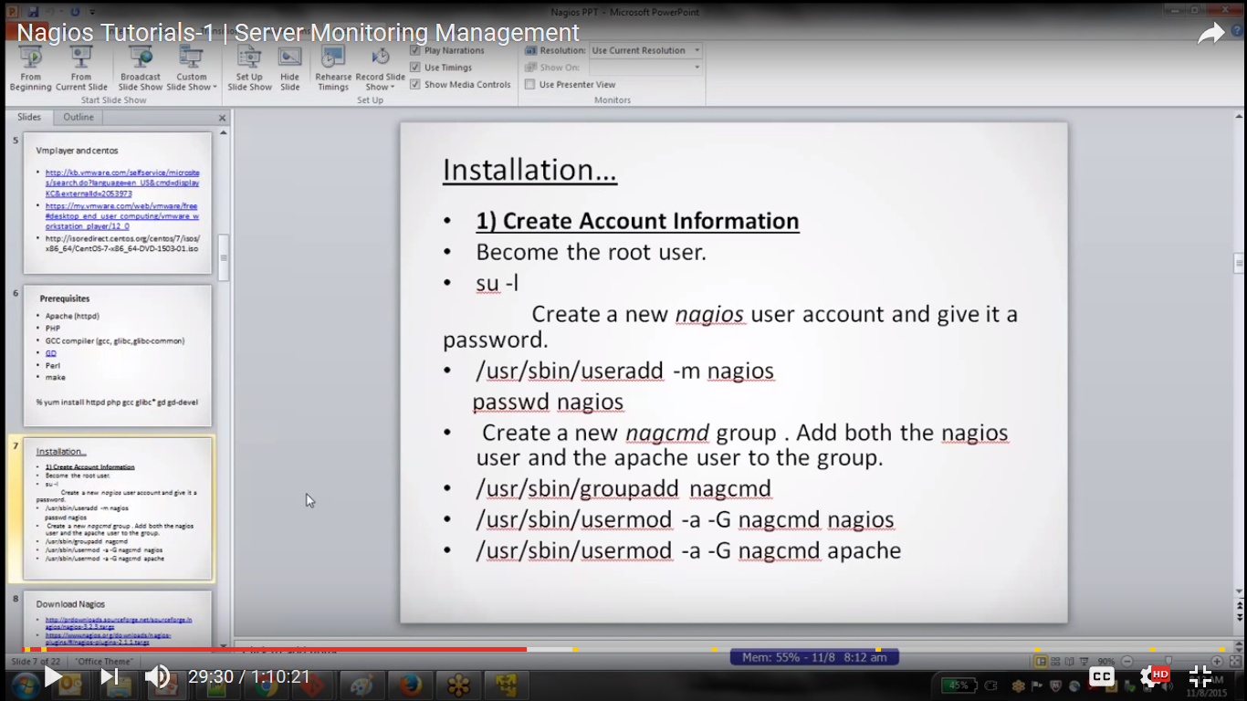

* Check the Nagios user id using command

$ id nagios

$ grep nagios /etc/passwd

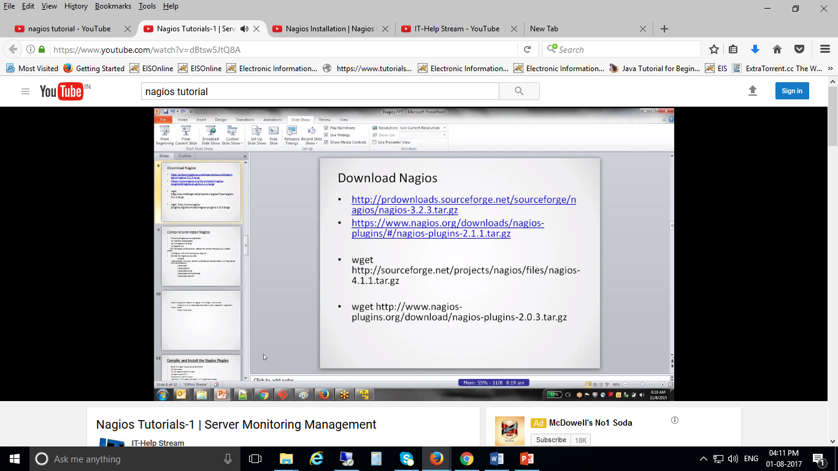

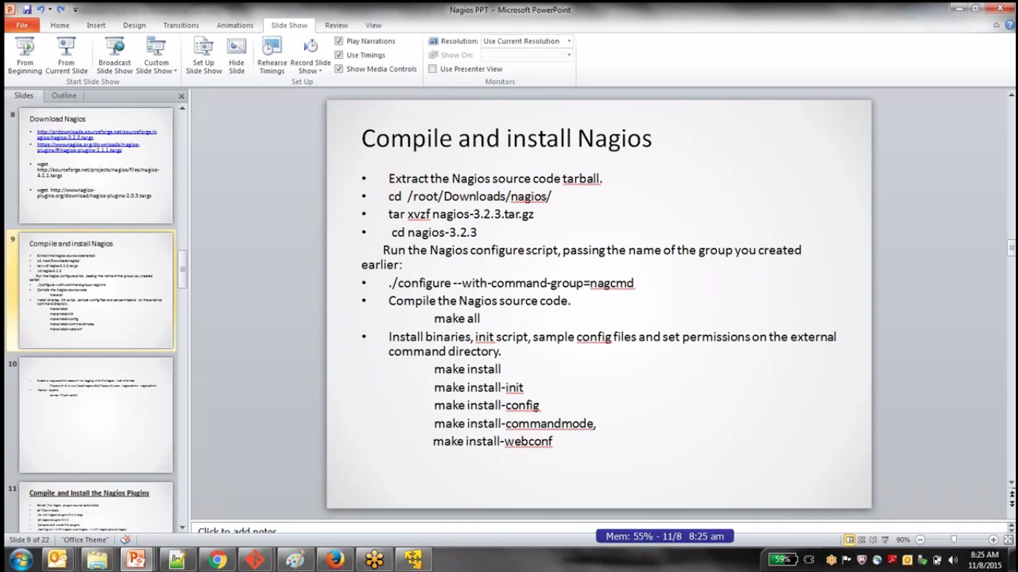

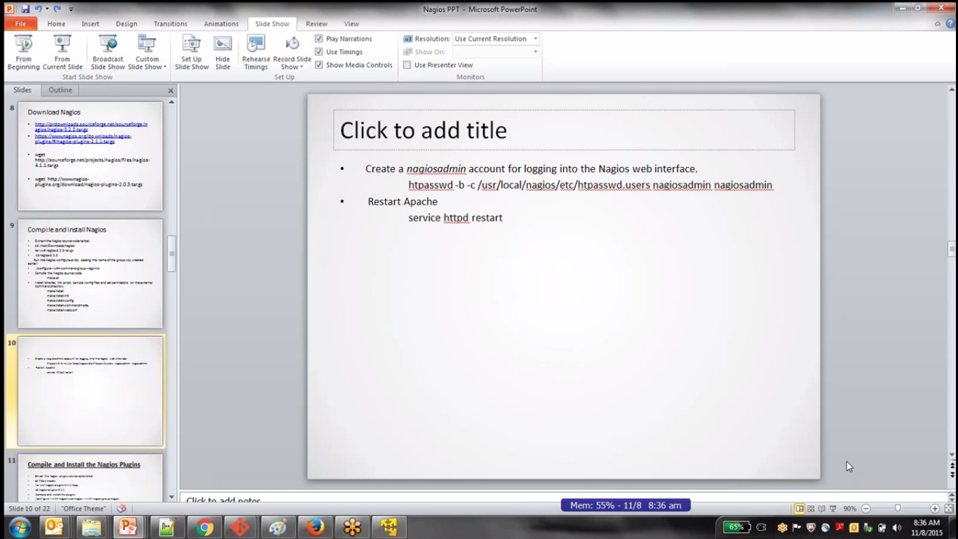

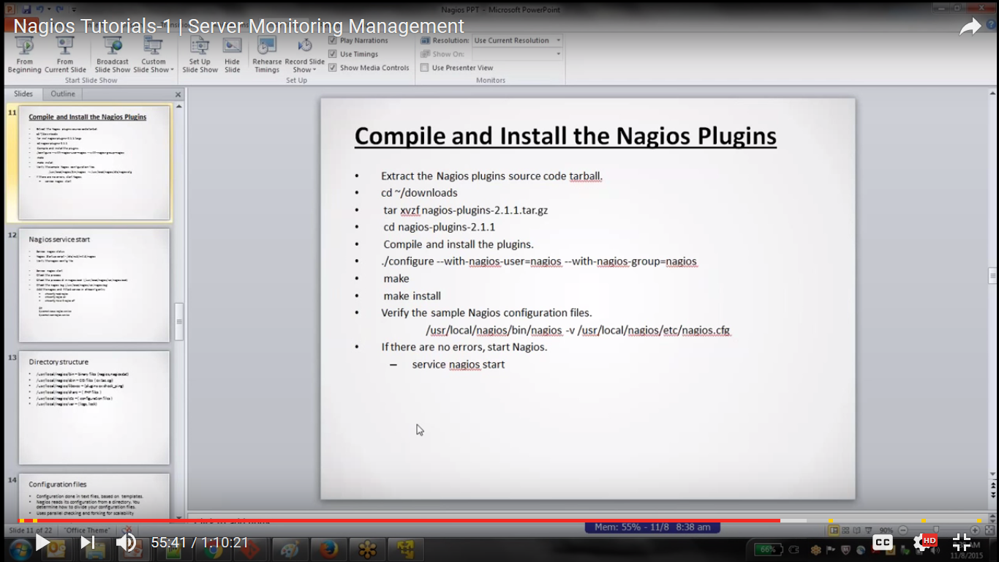

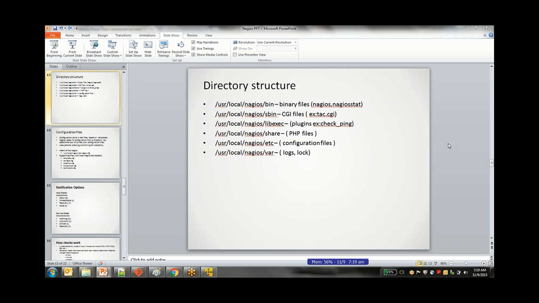

* Check the nagios process id

$ ps -ef | grep nagios

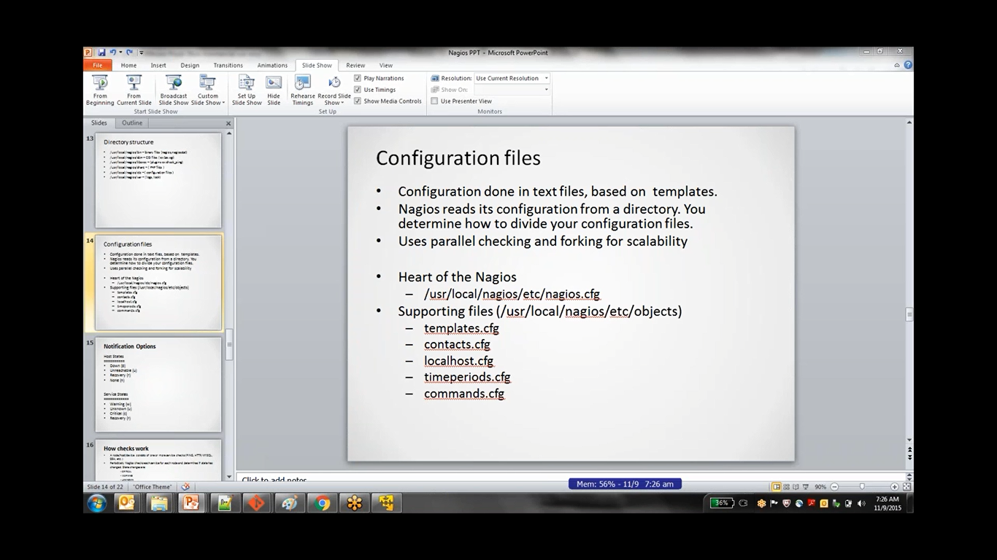

* When we run nagios first it will check for nagios.cfg file (it is template), using this file it will pick other configuration files
* “Commands.cfg” contains commands template means all the commands defined in this file and which plugin has to be call for what check
* /user/local/nagios/etc/resource.cfg file will help to configure repeat values, we can put reusable values in this file.
* Localhost.cfg file is use for configure connecting host details. We can configure any number of hosts here for that it having “define host” template. Will configure what are the services OR what are things we have to monitor for that it having “define service” template

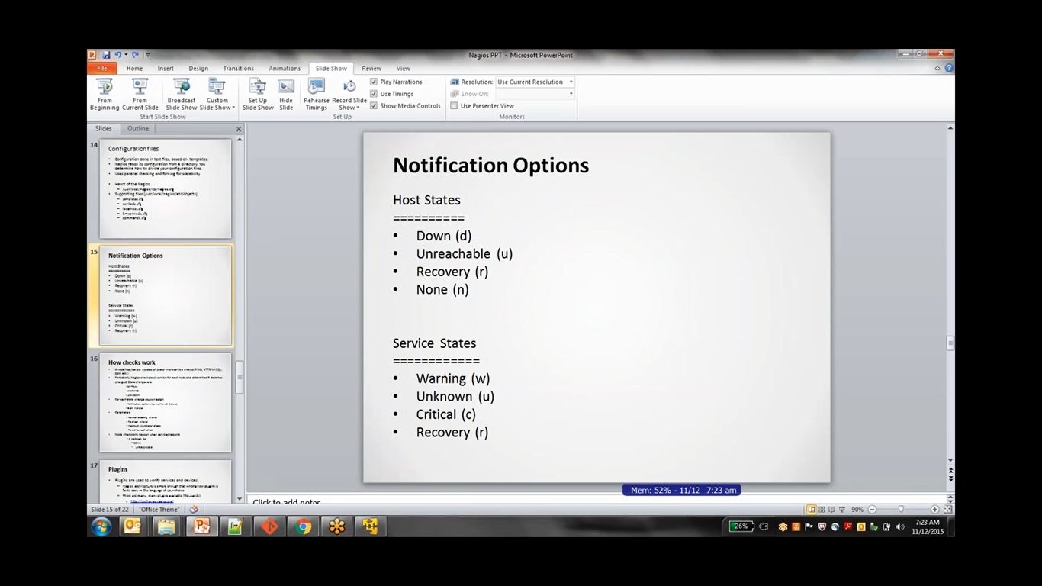 **drun cruw**

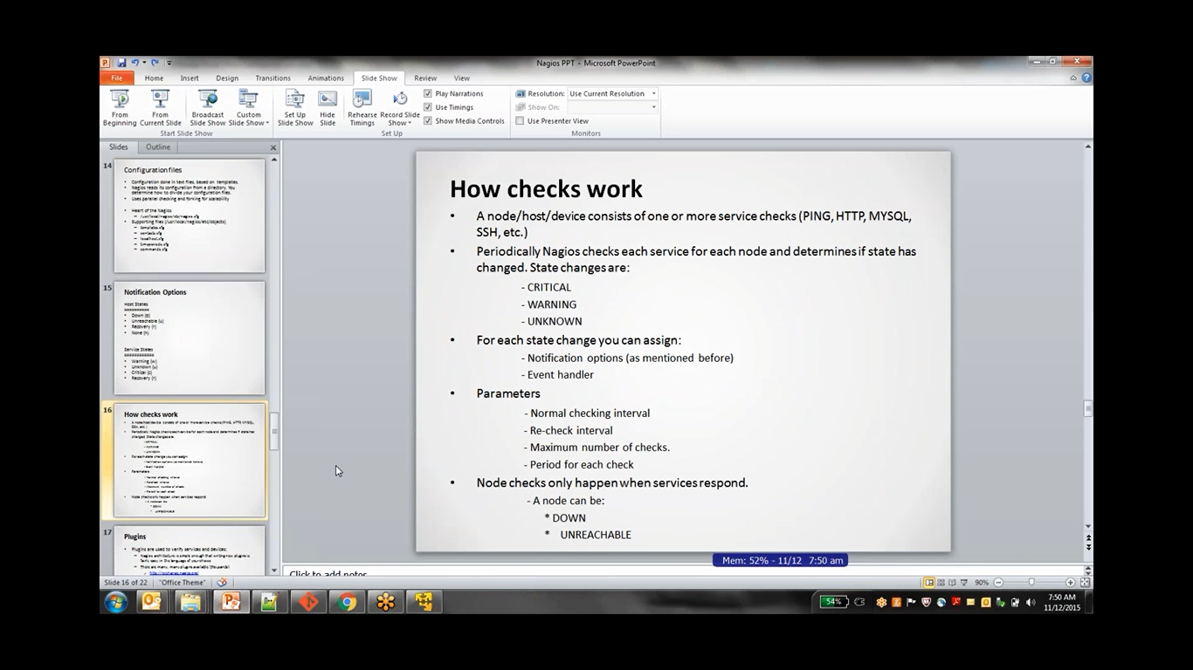

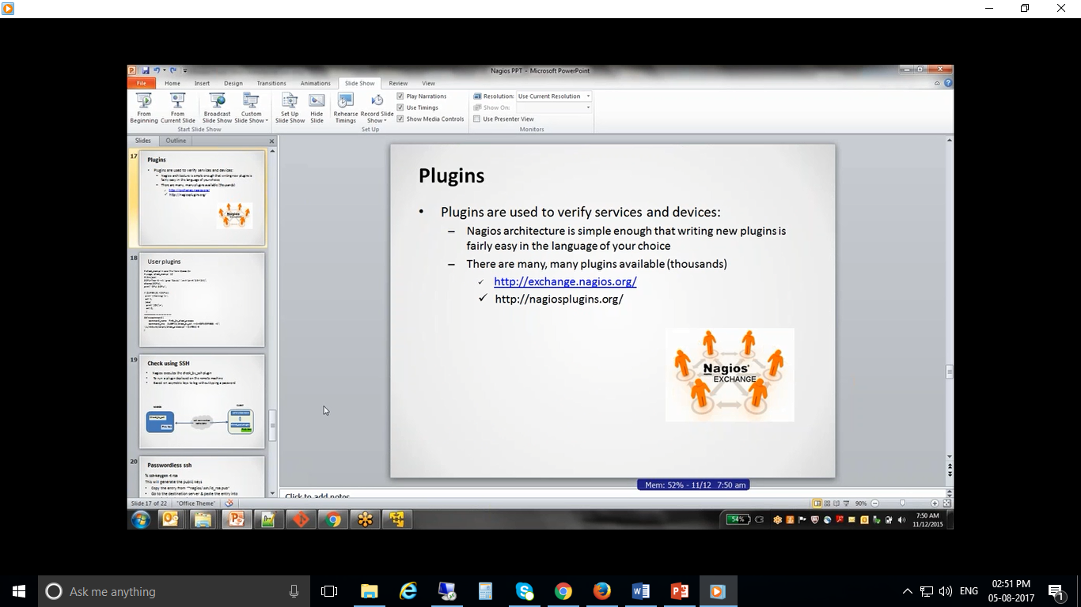

* Write our own plug in using perl, shall script, java script…
* Below one own plugin for CPU utilization in perl script.

